The Evolution of Artificial Intelligence: A Historical Journey from Foundations to Generative AI

Introduction
Artificial intelligence has evolved through a series of breakthroughs, setbacks, and renewed advances rather than through steady, uninterrupted progress. The Workshop 1 presentation presents this development as six major eras, beginning with foundational ideas in the mid-twentieth century and extending to the rise of generative AI in the 2020s. That structure is important because it shows that modern AI did not emerge suddenly. It is the result of decades of experimentation, changing research methods, improved computing power, and repeated lessons learned from earlier limitations. The central idea of this artifact is that AI history is best understood as a cycle of innovation, disappointment, recovery, and transformation.

Description
This artifact focuses on the AI Development: Six Major Eras section from Workshop 1. In that section, AI is presented as a historical timeline stretching from 1950 to 2024 across six distinct eras. The presentation explains that each era reflects changes in research priorities, computing power, funding, and public expectations. It also emphasizes that AI progress has not been linear. Instead, major breakthroughs were often followed by periods of slowdown known as AI winters. The six-era model helps explain how today’s generative AI systems emerged from earlier work in symbolic reasoning, neural networks, expert systems, machine learning, and deep learning.

Objective
The objective of this artifact is to explain the six major eras of AI development and show how each stage contributed to the rise of modern artificial intelligence. It is designed to help readers understand the historical path of AI, the reasons for its periods of growth and decline, and the significance of the current generative AI era.

Timeline
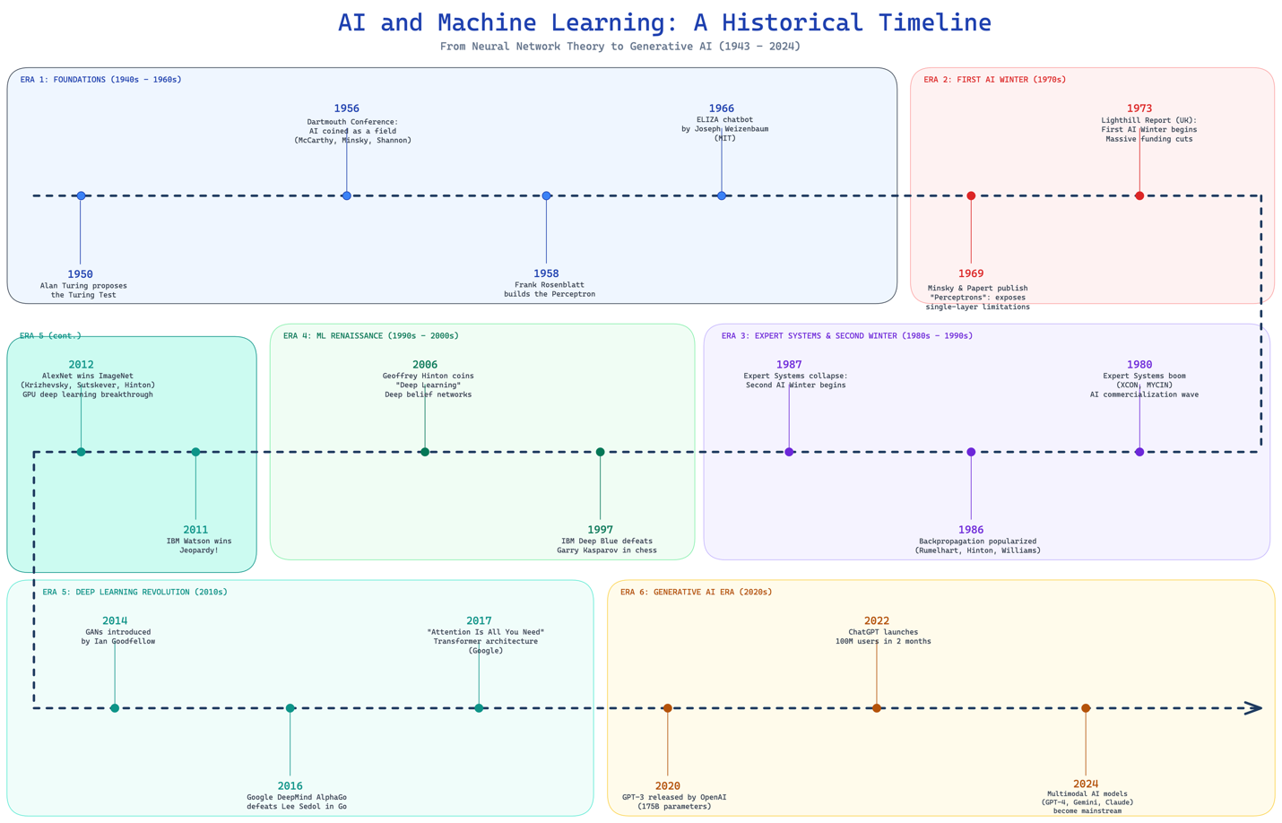

Process
The timeline was developed through a structured review of the cited resources:
- Identify the main historical section in the presentation.
- Review the six eras and the major milestones attached to each one.
- Extract the recurring themes across the timeline, including shifts in methods, computing power, and funding.
- Organize the material into a clear narrative that explains not only what happened, but why each stage mattered.
- Summarize the historical progression in a concise table and flow structure to make the artifact easier to read.

Tools and Tech Used
Research: The artifact was informed by external articles and sources cited in the references section, which provided the historical context, major milestones, and interpretation of AI development.
Analysis: Comparative historical analysis was used to connect each era to larger patterns of innovation, limitation, renewed investment, and technological progress.
Presentation: Microsoft PowerPoint was used to build and organize the presentation content.
Design: Excalidraw (https://excalidraw.com/) was used to create the timeline diagram, while tables and structured layout elements were used to present the information clearly and visually.

Value Proposition of the Artifact
This artifact provides value by turning a broad timeline into a clear explanation of how artificial intelligence developed over time. Instead of viewing AI as a single invention or a recent trend, the artifact shows it as a layered progression shaped by technical discoveries, market realities, and evolving expectations. This gives readers a stronger understanding of why today’s AI tools are powerful, why earlier systems fell short, and why responsible progress requires learning from the past.

Unique Value
The unique value of this artifact lies in its historical perspective. Many discussions focus only on current AI tools, but this artifact places present-day AI within a much longer story. By organizing the material around six eras, it becomes easier to see how the field matured, how setbacks redirected research, and how breakthroughs in one era often depended on lessons from a previous one.

Relevance
This artifact is relevant because current conversations about AI often focus on outputs without understanding the path that made those outputs possible. The Workshop 1 presentation shows that today’s generative AI systems are part of a larger pattern of progress shaped by research ambition, hardware advances, and practical constraints. That perspective is valuable for students, professionals, and decision-makers because it encourages a more realistic and informed view of AI’s capabilities and future direction. The presentation’s key takeaways also stress that AI develops in cycles and that hardware repeatedly enables major leaps in performance.

Summary of the Six Major Eras
Era | Time Period | Main Development | Historical Importance
Foundations | 1950–1966 | Turing Test, Dartmouth Conference, perceptron, ELIZA | Established AI as a research field and introduced the earliest competing approaches
First AI Winter | 1969–1973 | Criticism of neural network limits and lack of progress | Reduced optimism and funding, exposing the gap between ambition and technical reality
Expert Systems and Second AI Winter | 1980–1987 | Growth of rule-based expert systems and later market collapse | Showed commercial promise, but also the difficulty of scaling brittle systems
Machine Learning Renaissance | 1997–2006 | Deep Blue and revival of deep learning | Shifted attention toward data-driven methods and renewed interest in neural networks
Deep Learning Revolution | 2011–2017 | Watson, AlexNet, AlphaGo, transformers | Demonstrated the power of large datasets, better hardware, and modern neural architectures
Generative AI Era | 2020–2024 | GPT-3, ChatGPT, multimodal AI | Brought AI into mainstream public use and expanded its role in communication and content creation
The historical progression across these eras includes foundational milestones such as the Turing Test, the Dartmouth Conference, early neural network work, the expert systems boom, the revival of machine learning, the deep learning revolution, and the emergence of generative and multimodal AI.

Conceptual Flow of AI Development
Foundational ideas and early systems
↓
High expectations and technical limits
↓
Rule-based commercial success
↓
Collapse and reassessment
↓
Machine learning revival
↓
Deep learning breakthroughs
↓
Generative and multimodal AI

Looking Forward
The presentation concludes by noting that the future of AI will depend not only on technical performance, but also on ethical considerations, integration challenges, and sustainable development. As AI systems become more powerful, concerns about bias, fairness, accountability, reliability, safety, and environmental impact become more important. These concerns make historical understanding even more valuable, because the past shows that long-term success in AI depends on balancing innovation with practical responsibility.

References
Bhat, A. K. (2025, March 11). The evolution of AI: From foundations to future prospects. IEEE Computer Society. https://www.computer.org/publications/tech-news/research/evolution-of-ai
Milmo, D. (2023, February 2). ChatGPT reaches 100 million users two months after launch. The Guardian. https://www.theguardian.com/technology/2023/feb/02/chatgpt-100-million-users-open-ai-fastest-growing-app
Our World in Data. (2025, January 21). Since 2010, the training computation of notable AI systems has doubled every six months. https://ourworldindata.org/data-insights/since-2010-the-training-computation-of-notable-ai-systems-has-doubled-every-six-months
Roser, M. (2022). The brief history of artificial intelligence: The world has changed fast—what might be next? Our World in Data. https://ourworldindata.org/brief-history-of-ai

